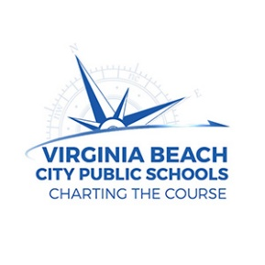
Sustainability Coordinator
Virginia Beach City Public Schools
2023

General Responsibilities:

The Sustainability Coordinator works closely with the Sustainability Officer to assist in providing leadership, alignment, coordination and delivery in the development and improvement of sustainability initiatives across the school division. The coordinator works closely with schools to ensure that resources are available for staff and student to use to implement division wide sustainability goals.

Essential Tasks

- Serve as instructional point person for division-wide sustainability initiatives.
- Develop and update programmatic materials.
- Review and analyze relevant data for the program.
- Work with the Sustainability Officer to develop short and long-term goals for sustainability, with an emphasis on K-12 instruction and specialty programs .
- Develop, plan and conduct professional development activities, programs and conferences for administrators, instructional staff and trainers for division-wide sustainability initiatives.
- Work collaboratively with staff members of other departments as assigned
- Develop, update and maintain the program’s website
- Serve on a variety of local and state committees, representing the school division
- Perform related work, as required

Additional Duties

- Communicate the vision, mission and goals of the sustainability program to all stakeholders
- Direct and maintain day-to-day operation of the program
- Support liaisons and other staff members associated with the sustainability program
- Conduct research to prepare and write grants to secure additional funding for the program
- Promote sustainability programs to students, parents, universities, potential employers and the community

Knowledge and Skills

Must possess a thorough knowledge of the principles and practices of sustainability, including understanding of triple-bottom-line thinking; comprehensive knowledge of curriculum, program and budget development; Must have the ability to analyze information and evaluate results to choose the best solution and solve problems; ability to guide and train support staff; ability to develop and present ideas effectively, orally and in written form; ability to establish and maintain effective working relationships with school administrators, teachers, staff, and the general public.

Education and Experience

Bachelor’s Degree in education and five (5) years teaching or leadership experience.

Physical Requirements

Some standing, walking, moving, climbing, carrying, bending, kneeling, crawling, reaching, handling, pushing and pulling

